Applications Of Information and Communication and Technology Lab
Lab 5
Excel Advanced
(Charts and Pivot Tables)

o Lab number: 4
o Lab Title: Excel Advanced
o Submitted by: Muhammad Ibrahim Siddiqui
o Submitted to: Mr. Adnan Jelani
o 9/28/2026
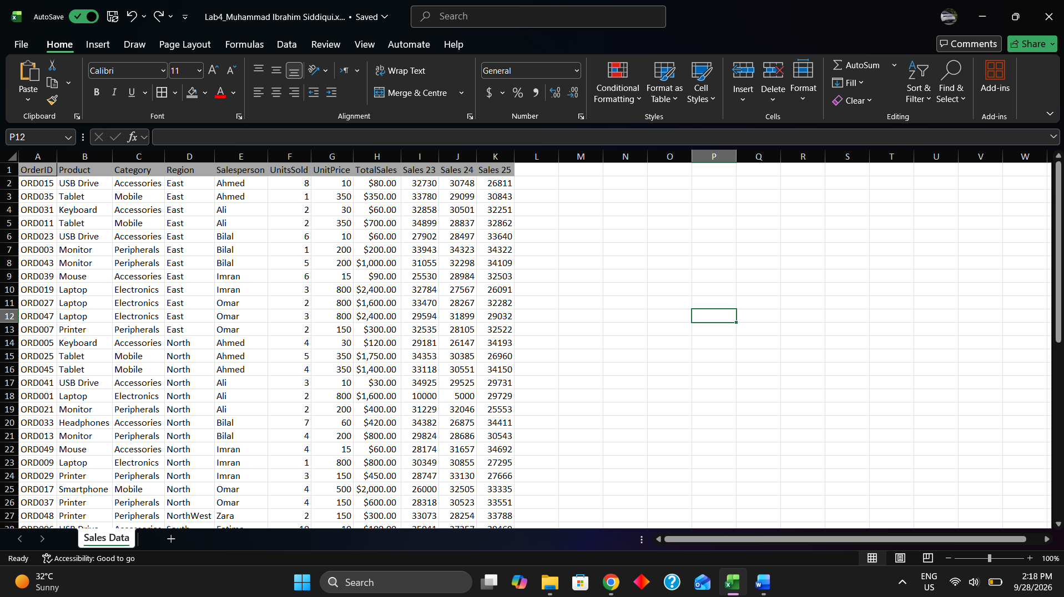
Task 1:

Task 2:
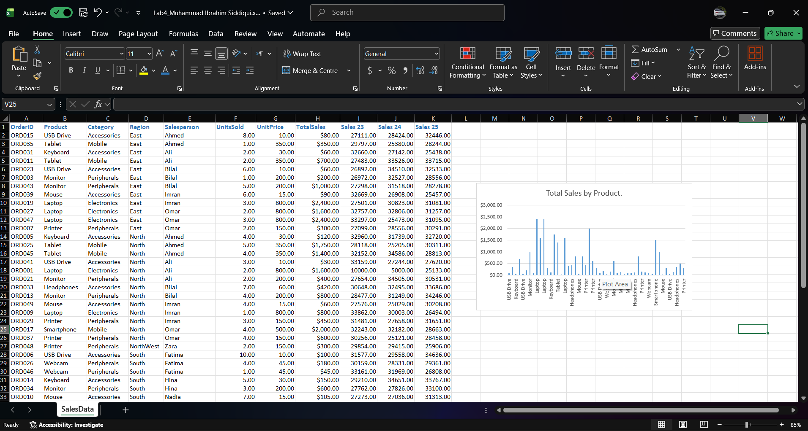
Task 3:

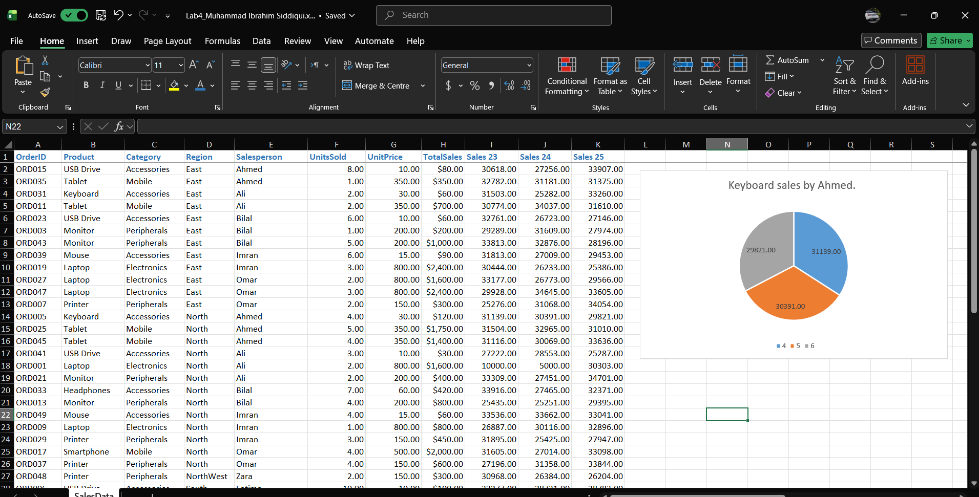

Task 4:
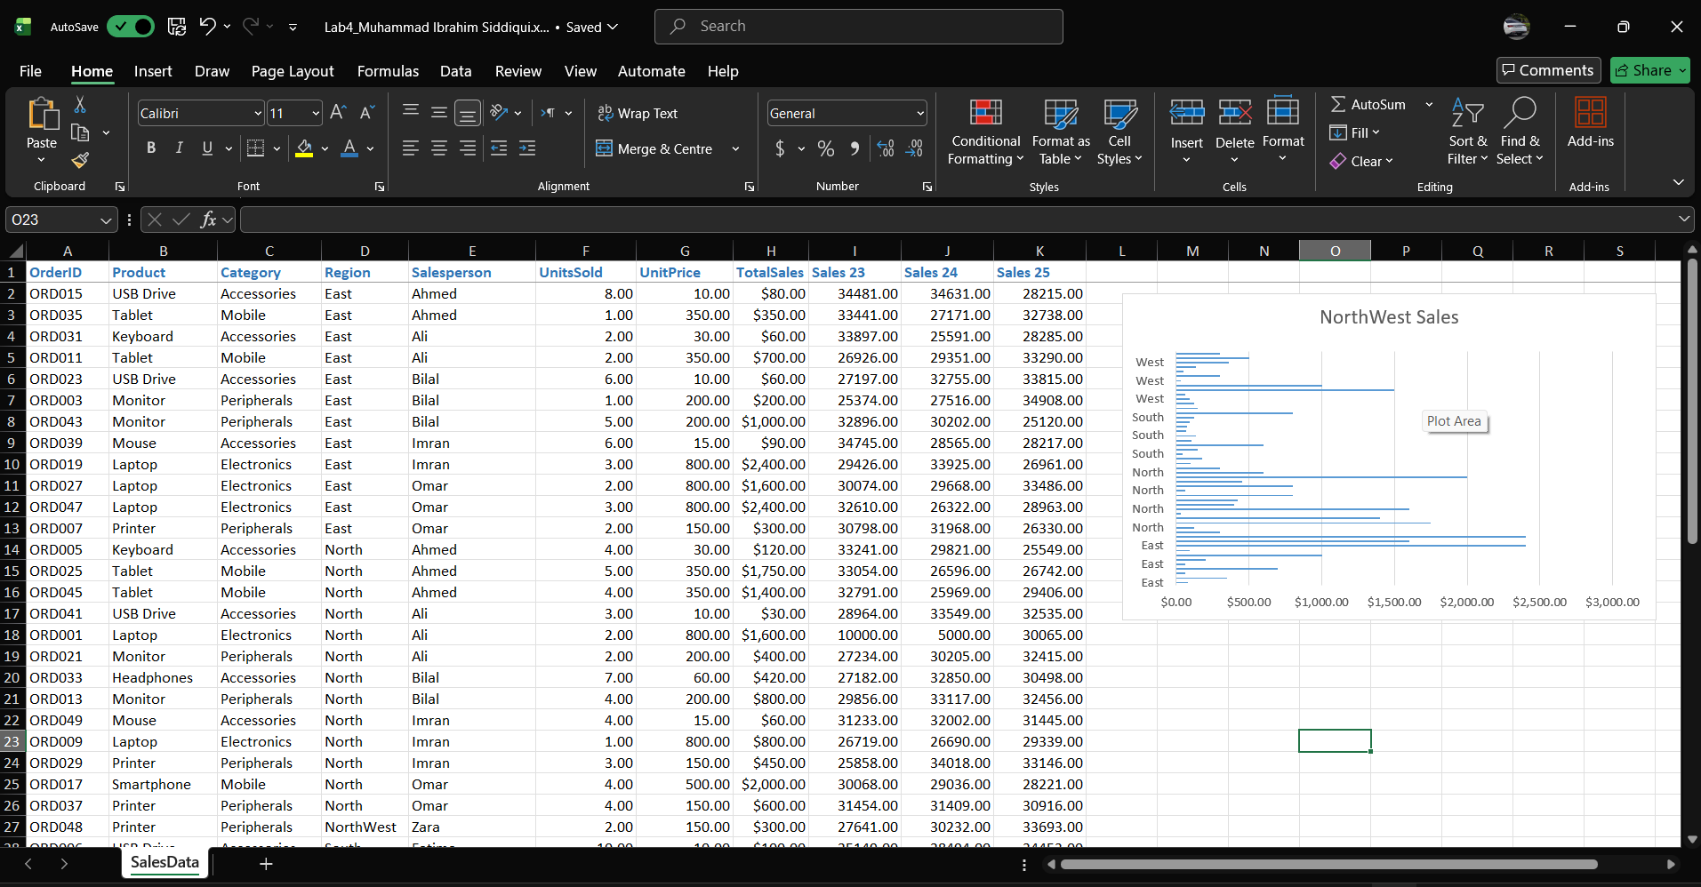

Task 5:
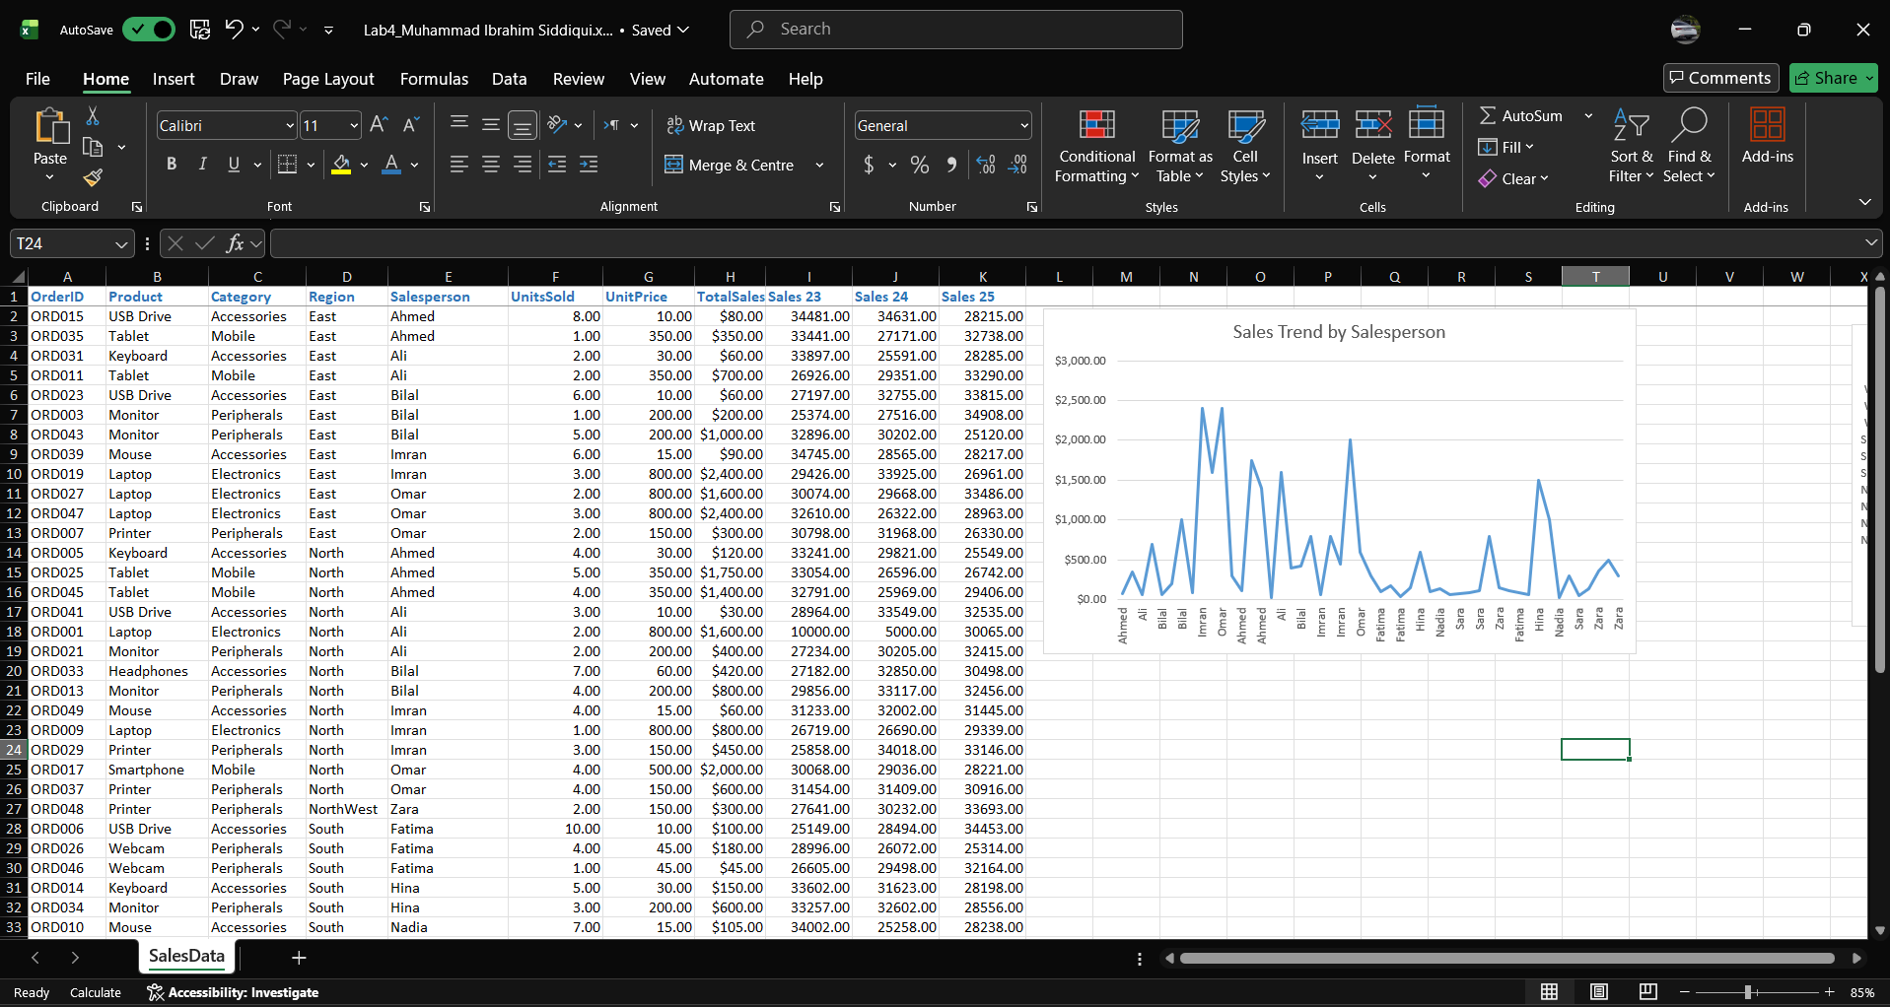

Task 6:
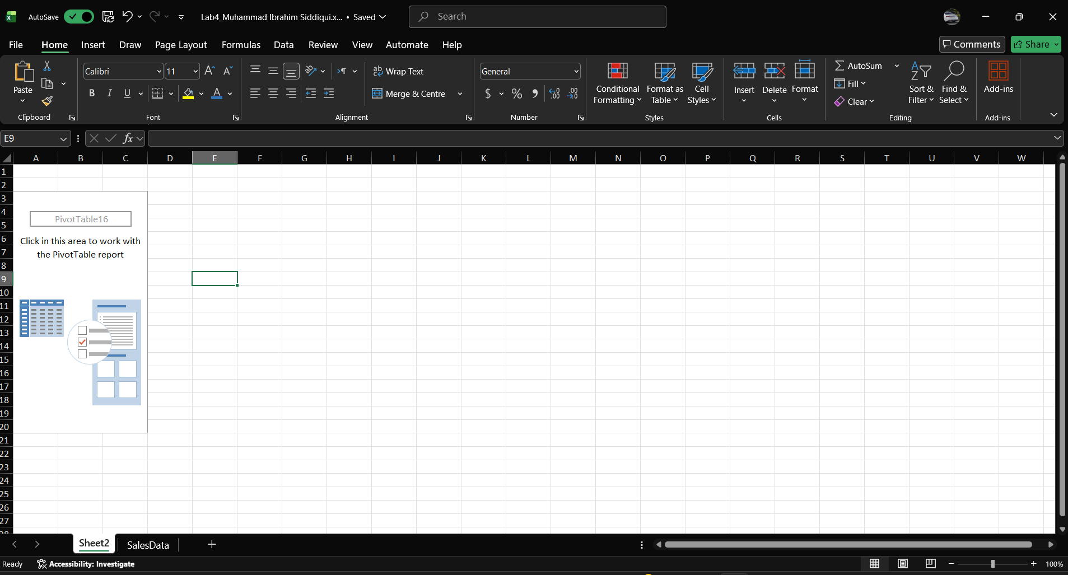

Task 7:
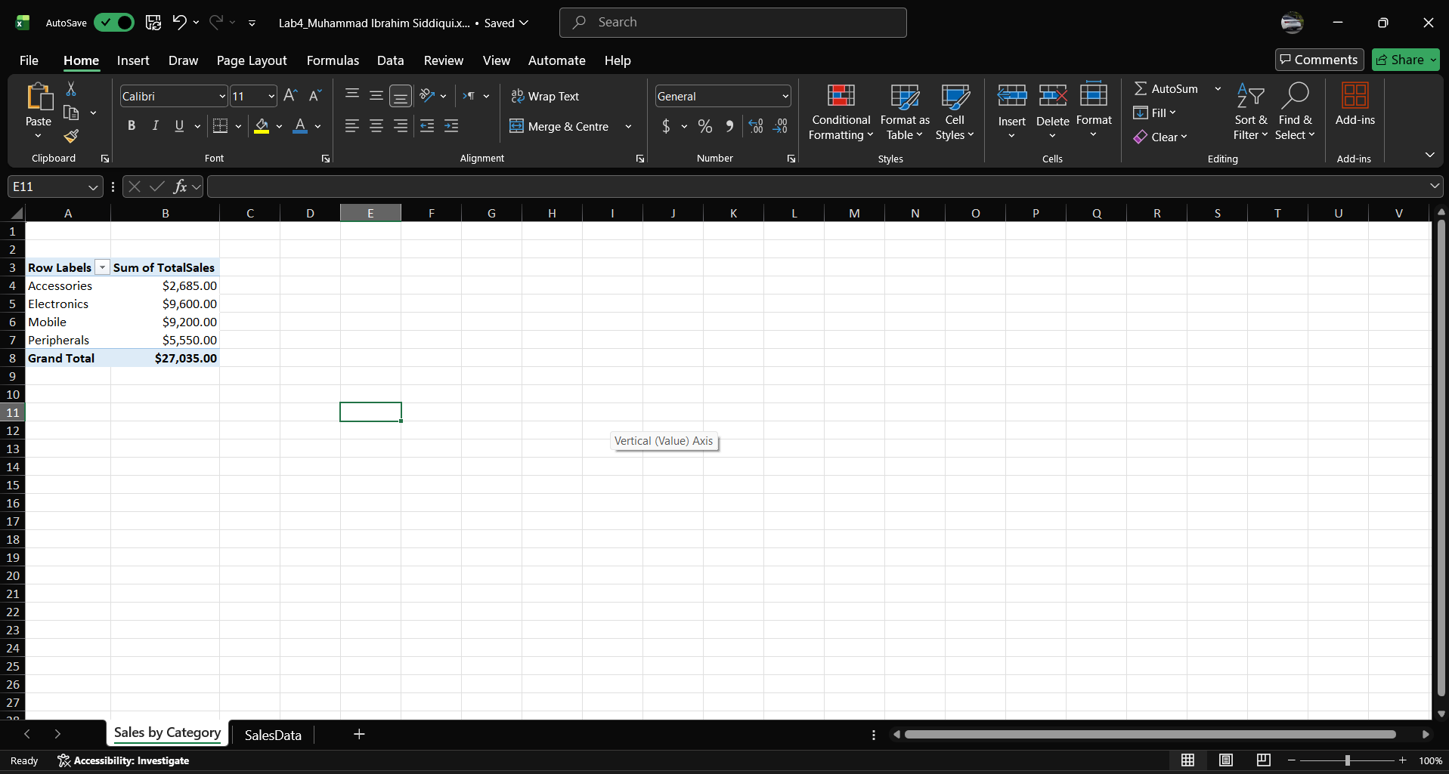

Task 8:
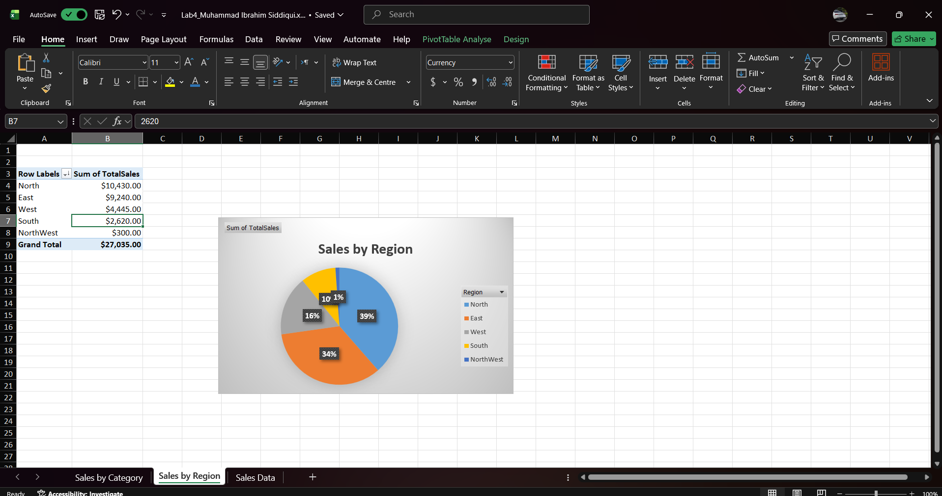

Task 9:
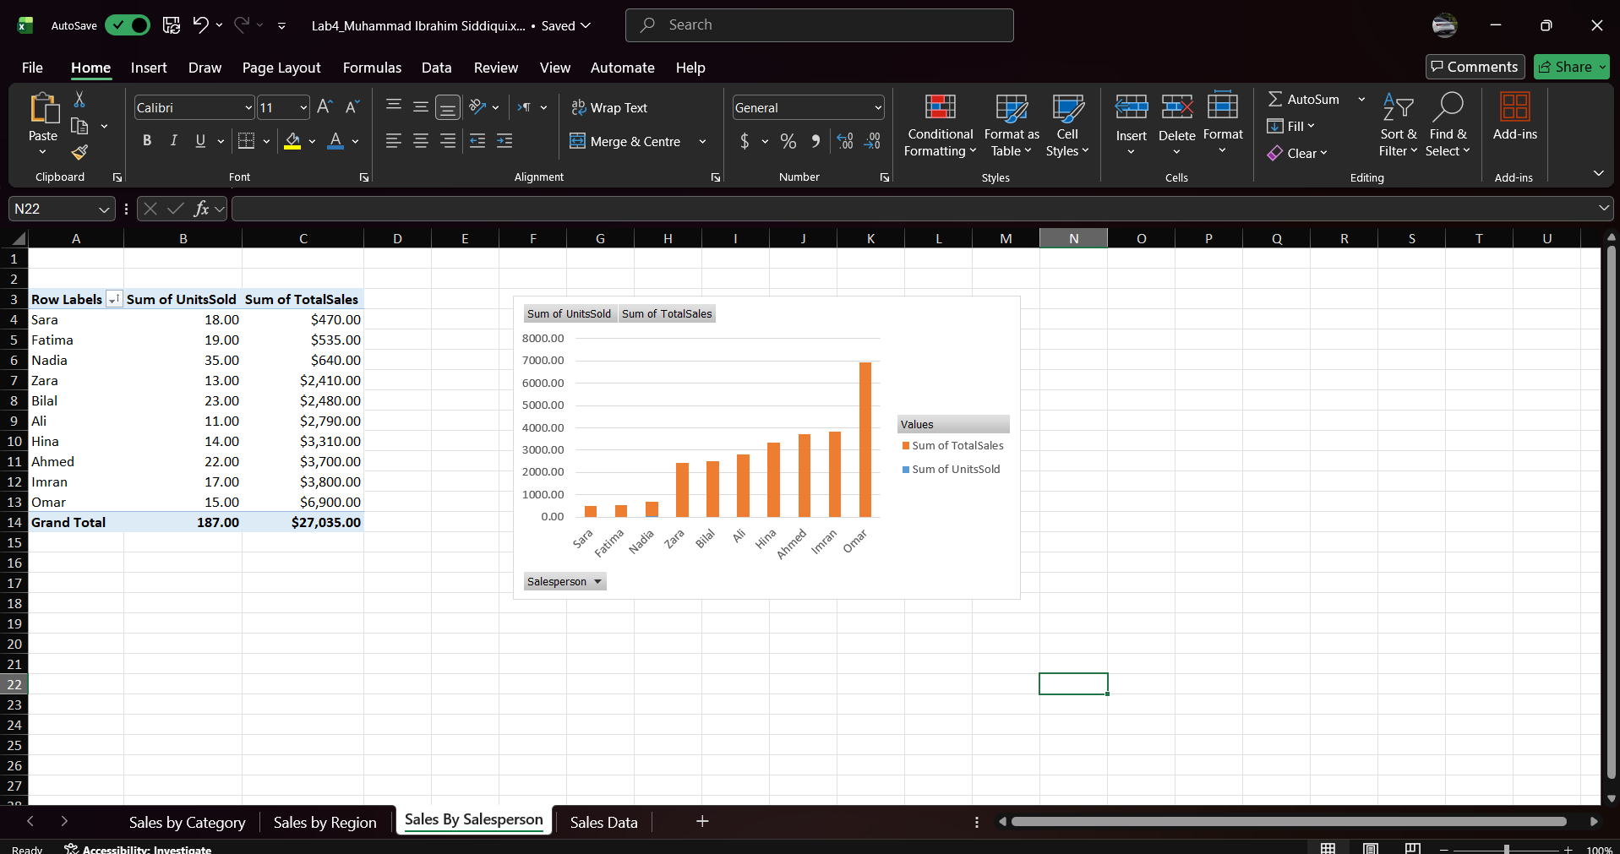

Task 10:
